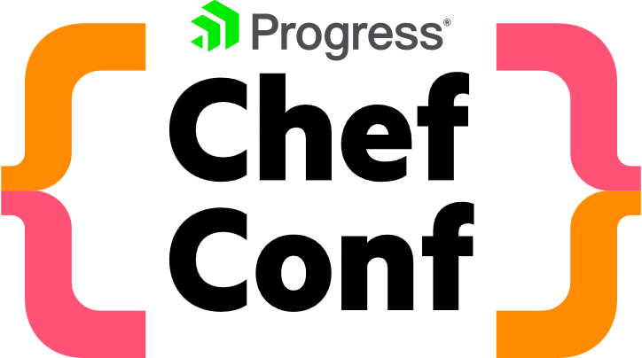

ChefConf will provide ample opportunity to network with peers, engage with   
industry experts, meet with Progress Chef leaders—oh, and have fun.

**Develop Your Skills**

Tap into a prime opportunity for learning and personal development. If you’re interested in staying at the forefront of DevSecOps ChefConf is the place to dive into all three. Great minds will come together to provide thoughtful content and meaningful guidance, all while putting trends in a larger context.

**Influence the Influencers**

Connect one-on-one with key executives and thought leaders to discuss your needs and provide the critical customer insights we use to determine future product roadmaps. There’s no substitute for an engaging conversation with someone you might never meet otherwise. Attending in-person provides an immersive experience that’s hard to match.

**Enjoy Yourself**

Step away from your desk monitors and home offices and forge human connections in a lively venue designed to stimulate and inspire. ChefConf offers opportunities to swap stories with like-minded peers and thought leaders in a way you can’t accomplish online.

**Free Associate Chef Certification for ChefConf'23 attendees!**

As a ChefConf'23 attendee, you'll have the exclusive opportunity to earn a free Associate Chef certification.

Complete the certification program before or during ChefConf to receive a Chef Certified Associate Engineer certificate. Post-event, the program costs $199. Check the [blog link](https://www.chef.io/blog/progress-chefconf-23-offers-a-free-certification-for-career-advancement) for more details.

**Request to attend ChefConf <insert Seattle, Washington, or Germany>**

To: < Insert manager or supervisor name >

Subject: How my attendance at ChefConf will benefit our business

I’m requesting approval to attend the ChefConf conference in

**Seattle, Washington September 26 and 27, 2023 or   
Germany October 12 and 13, 2023**

By attending, I can gain insights that will enable me and my team to optimize our software infrastructure stack and drive faster cycles of innovation as well as help achieve our organizational goals. This a once-a-year opportunity to learn from industry experts and Progress leaders will further my development and enable me to learn new skills and best practices that can improve our company operations and technology decision making.

I’ll connect with peers who are adopting new business applications and processes enabled by Progress—from configuration management, and deployment and compliance and security within the DevSecOps space and more.

My pass includes access to DevSecOps sessions, workshops, demos, and networking opportunities featuring 30+ technical sessions delivered by industry experts. ChefConf is the event for DevOps professionals that will dive into the latest innovations and practices in DevSecOps, compliance and security, IT leadership and IT operations. potentially influence future product direction.

As a ChefConf'23 attendee, I also have the exclusive chance to earn the Associate Chef certification without any cost. This certification holds significant value as it will not only enhance my skills and expertise with Chef but also enable me to bring back valuable insights and knowledge to our team.

If I’m able to attend ChefConf, I’ll come back with actionable tips, products, and practices to drive business outcomes. My conference schedule will reflect our highest priorities.

< Insert conference session>

The estimated conference investment: <insert total estimate $>

* 2-day conference ticket. $499
* Airfare
* Hotel

Please let me know if you have questions. Thank you for your support in helping me further our company’s success.

Sincerely,

< Your name >